**F-Lab #2**

**Manufacturing a Bistable Gripper System**

Group Name: ___________

Members

Name (leader): __________________________ ID: __________________________

Name : __________________________ ID: __________________________

Name: __________________________ ID: __________________________

Name: __________________________ ID: __________________________

Name: __________________________ ID: __________________________

We ask you to build a **robot arm** made up of linkages combined with bistable structure. This activity may motivate you to in-depth learning of multi-DOF linkages with bistability mechanism while you build a simple device with fun.

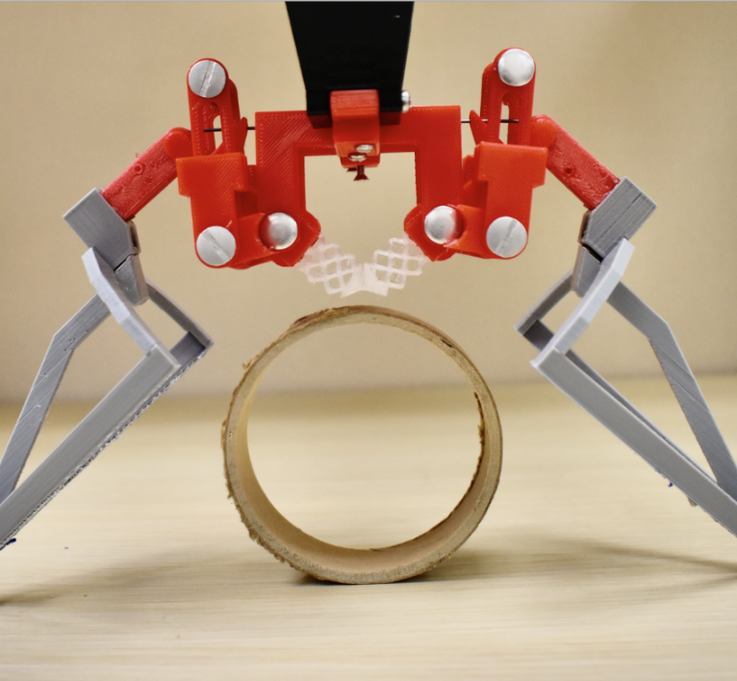

*Sample videos: uploaded on CANVAS (you may check this video for a clear understanding of the device.)

*Note*: Your device does not have to be the same as the one in the videos; you may choose different materials for parts and dimensions.

**Parts and tools needed**

日程表

AI 生成的内容可能不正确。

While prototyping, you may answer these questions and include them in your **technical report**.

**1. Design Synthesis and Justification**

This section explains *what* you designed and *why* you made your specific design choices.

1. **Mechanism Concept:** Provide a clear, labeled sketch of your final gripper design. Identify the key materials used for each component (e.g., “popsicle stick linkage,” “thin wood board spring element”).
2. **Principle of Bistability:** Explain in detail how your design achieves bistability. Did you use an **elastic, compliant element** (like a bent wood board) or a **geometric linkage** (like an over-center or toggle mechanism)? Describe the components responsible for storing and releasing the energy that creates the “snap” action.
3. **Dimensional Justification:** Justify the key dimensions of your gripper. Explain how the size and shape of your jaws are designed to effectively grasp the 10cm diameter cylinder when the mechanism is in its closed state. Explain why you chose the specific lengths for your links or the shape of your compliant element.

**2. Analysis of the Gripper Mechanism**

This section demonstrates your understanding of the underlying principles of your design.

1. **Kinematic Analysis:**

i. Draw a simplified kinematic diagram of your gripper mechanism.  
ii. Identify the total number of links (L) and the number of joints (J). Specify if the joints are revolute (pivots) or sliding.  
iii. Based on this, analyze the mobility (degrees of freedom) of your mechanism. Does the theoretical mobility match the actual motion you observe?

1. **Energy State Analysis:** Describe the three critical phases of your gripper’s operation:

i. **Stable State 1 (Open):** Describe the configuration of the gripper. Where is the potential energy stored?  
ii. **Unstable Transition State (The “Tipping Point”):** Describe the point where the gripper is about to “snap.” What has to happen to get it to this point?  
iii. **Stable State 2 (Closed/Locked):** Describe the final configuration. How does this state securely hold the object without external power?

**3. Prototyping, Technical Issues, and Iteration**

This section reflects on the real-world challenges of turning a design into a functional object.

1. **Observed Problems:** Describe at least two technical problems you encountered during fabrication or testing. Examples could include:

* The mechanism did not “snap” cleanly or required too much force.  
* A component broke or bent unexpectedly.  
* Friction in the joints prevented smooth motion.  
* The final grip was too weak or did not conform to the cylinder.

1. **Proposed Corrections:** For each problem you identified, propose a specific design modification to resolve it. Explain *why* you believe this change would improve the performance. If you had time to rebuild your prototype, what would you do differently?

**4. Bonus (maximum 10 pts): Servo Actuation**

If your group attempted the bonus task, complete this section.

1. **Trigger Mechanism Design:** Provide a sketch and a detailed description of how you integrated the SG90 servo motor to trigger the bistable mechanism. Explain how the servo’s motion provides the necessary force to push the gripper past its unstable tipping point.
2. **Performance and Verification:** Describe the performance of your servo trigger. Did it work reliably? Crucially, confirm that you were able to demonstrate the “power-off hold”: the gripper remained securely locked on the cylinder after the servo was deactivated.

**5. Team Member Contributions**

To ensure fair evaluation of teamwork, please list each team member and provide a brief, specific description of their primary contributions to the project.

* *Example:*
  + *Member A: Led the initial design of the over-center linkage and performed the kinematic analysis.*
  + *Member B: Fabricated and assembled the main gripper structure and jaws, focusing on pivot quality.*
  + *Member C: Designed and implemented the servo trigger mechanism for the bonus task, and led testing.*
  + *Member D: Compiled all sections into the final report and created the diagrams and sketches.*

Submission types:

1. The device your group has prototyped (a video file) - **40 points**
2. Report (**<15 pages**) – **60 points**